1. By definition, a tetromino has four unit squares. **D**
2. A T-block has 10 edges of a unit square along its perimeter. Therefore, each unit squarethat makes up a T-block has a side length of 1. So, the area of each unit square is 1, and since there are 4 of them the total area is 4(1) = 4 **C**
3. A 3x3 solid square requires 9 unit squares to be made, but each tetromino piece is consisted of 4 square units, so it’s not possible to make a 3x3 solid square using a whole number of tetrominoes. **E**
4. The T-block has six 90° and two 270° internal angles. The L-Block has five 90° and one 270° internal angles. The Line-Block has four 90° internal angles. Adding this all together the total value of the internal angles for these three blocks is 2160°. **D**
5. The dimension of this pool is 4x4x2 rectangular box. The space diagonal of this box is. If simplify this, the answer is 6 **D**
6. 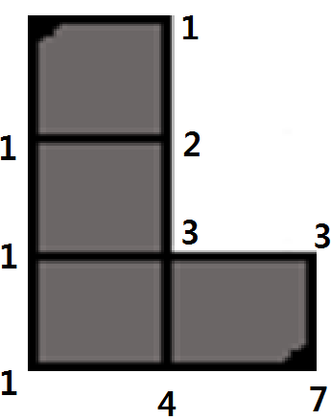 **A**
7. A and B are similar shapes and they have a side length ratio of 5:4. Therefore, the area ratio of these two similar shapes would be the square of the length ratio, which is 25:16. **C**
8. The formula for the number of N-gon is . In this problem, N = 2014-30 = 1984. Substitute this number into the formula, we will get  =  =  = 405. **B**
9. If we rearrange these points in the order of the vertices on the quadrilateral, the order would be (2,7) (2,3) (5,2) (10,15). Applying shoelace formula on these points, the area of the figure created by connecting these points would be 38. **D**
10. Because of the definition of the centroid, the centroid point of this figure would be the intersection of the lines that divide this L figure in half. If we use the lines perpendicular to x-axis and y-axis for the convenience, we can find that x = and y = 1 are the lines that divide the figure into half. Therefore, the centroid of this figure

would be (, 1). **A**

1. Because the slant height and the diameter of this cone are 5 inches, we will get an equilateral triangle if we cut this cone along the center of the cone. Therefore, the height of this cone is. Therefore, the volume of this cone would be  = . **A**
2. 8:37PM – 1:12PM = 7:25 PM. So () has been playing Tetris for 7 hours and 25 minutes. Because each hour is one rotation, or 360 degrees: = 2520 + 150 = 2670. The minute hand has swept 2670 degrees in this time period on an analog clock. **D**
3. Adding 7 hours and 37 minutes to 12:48 gives a time of 8:25. Applying the formula for angle between clock hands on an analog clock,  gives  = 102.5 degrees. **B**
4. In a cyclic quadrilateral, opposite angles always add up to 180°. Therefore, 134° + *x*° = 180°. Solving for *x*°, we get *x°* = 46° **A**
5. Because they are independent, the next piece can be any kind of piece. Therefore, the probability that the next piece is also a line piece after this turn is . **A**
6. The converse is not always true. So the answer is No. **B**
7. None of tetrominoes have 0 odd vertices, so there is no Eulerian Circuit among the tetrominoes. **A**
8. Z, reverse Z, and T block each have 2 odd vertices, so there are 3 Eulerian Path among the tetrominoes. Check the written solution for a picture. **D**
9. The volume of the sphere is and the volume of each individual button is . Since there are two buttons, the volume of one button must be multiplied by two. Substituting  for,. Rearranging and solving for  gives  **C**
10. The volume of the cylinder with radius  and height 8 is = 72. Since each Tetris pieces consists of four unit blocks and each unit block has a volume of 1, the volume of each Tetris piece is 4. Therefore, the total volume divided by the volume of a Tetris piece is the number that can be made from the magical Jell-O.  = 18. **C**
11. There are a total of 17 unit squares along the surface of the T-Block. The shortest side of a T-block is the same as the side length of one unit square. Since the shortest side is length 2, that means each unit square has an area of 4. The total surface area is found by multiplying the number of unit squares by the area of each unit square. 4(17) = 68. **C**
12. There are seven different kinds of tetrominoes, meaning the shape is a regular heptagon. The area a regular shape is defined as .5(perimeter)(apothem). In this case, the apothem is equal to the radius of the circle, since the heptagon is circumscribed about it. Therefore, the area of the heptagon is  = 168 **A**
13. The Platonic Solids are regular, convex polyhedrons with regular faces and the same number of faces meeting at each vertex. There are give polyhedrons that satisfy this, and number of faces on each solid is 4, 6, 8, 12, and 20. The sum of these numbers is 50. **D**
14. The formula for an area of a circle is π*r*2. Plugging in the radius, the area of the home button is 25π mm2. **D**
15. Since each unit square has an area of 1 and there are four unit squares in each Tetris piece, the area of one Tetris piece is 4. 50 divided by 4 is 12.5. Since you cannot have half a piece, the value must be increased to the next highest whole value. So, the answer is 13. **B**